CareerOps V1 —Documentation

Summary
CareerOps V1 is an AI-powered resume analysis platform designed to help candidates evaluate and improve their resumes.
The platform provides:
- Resume Parsing
- Skill Extraction
- ATS Analysis
- Experience Classification
- Job Matching
- Semantic Matching
- AI Recommendations
All AI recommendations are generated locally using Ollama-hosted language models.
No cloud AI providers are used.

V1 Architecture
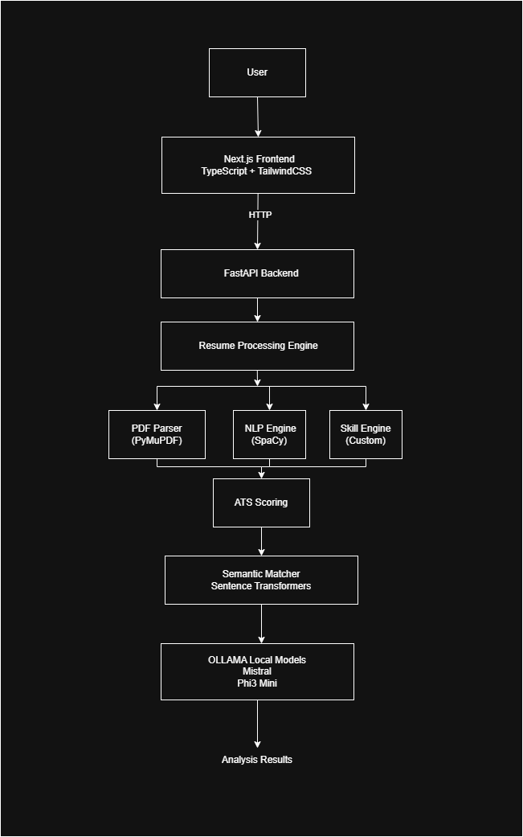
Resume Processing Flow
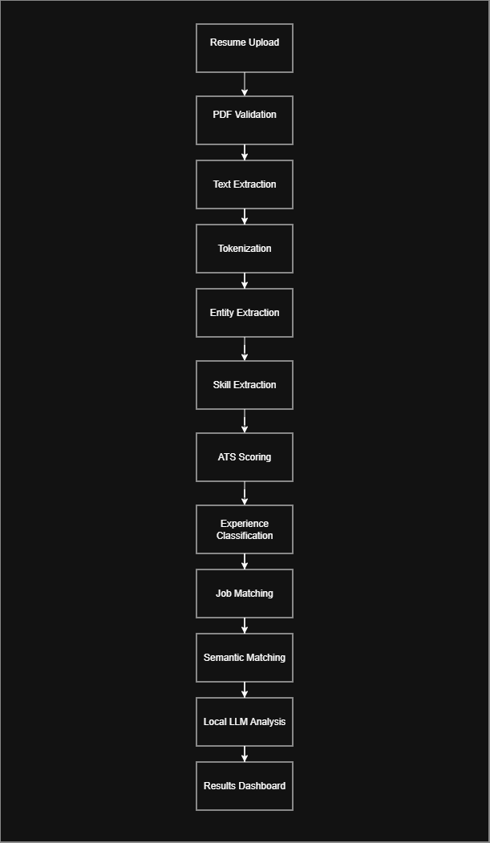
V1 Folder Structure
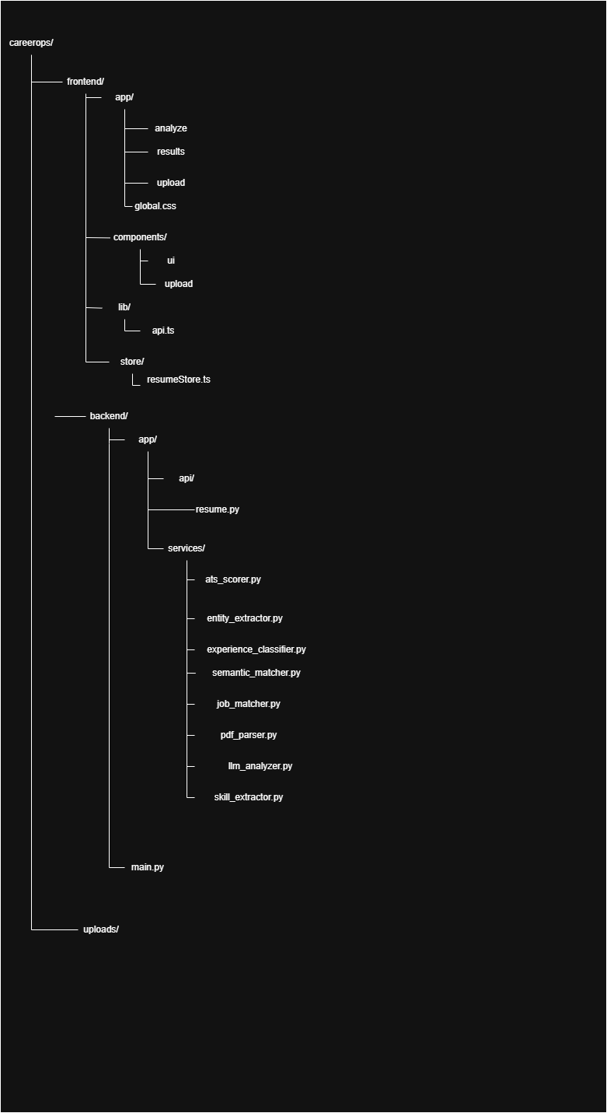

V1 Component Diagram
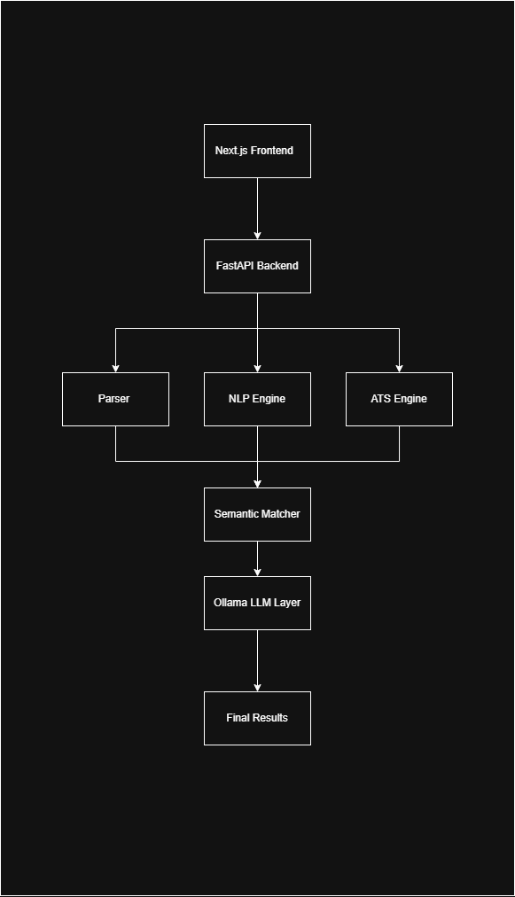
V1 Strengths
Fully Offline
No cloud dependency.
Privacy Friendly
Resumes never leave the machine.
No API Costs
Runs completely free.
ATS Analysis
Provides scoring and recommendations.
Semantic Matching
Uses Sentence Transformers.
Multiple Models
- Mistral
- Phi-3
V1 Limitations
Local GPU Required
Ollama requires local resources.
Slow on Low-End Machines
Inference depends on hardware.
No User Accounts
Analysis not saved.
No Database
Results lost after refresh.
No Cloud Deployment
Only local execution.

